CASE STUDY - BTCWires
Building a High-Availability Crypto & Blockchain Media Platform

1. Client Overview
BTCWires is a digital media platform specialising in cryptocurrency and blockchain industry coverage. The platform delivers breaking news, in-depth editorial content, live market pricing, interactive market heatmaps, and AI-generated news summaries serving a global readership that surges dramatically during periods of crypto market volatility.

2. The Challenge
BTCWires needed a production-grade cloud platform capable of operating reliably under highly unpredictable load conditions. Crypto markets never sleep and news-driven traffic spikes can arrive with virtually no warning, routinely reaching 10–15 times normal volume within minutes of a major market event.
Key requirements included:
- A real-time data pipeline capable of ingesting, processing and surfacing live market data prices, volumes, heatmaps with sub-second freshness.
- An application tier that could scale automatically and elastically to absorb extreme traffic spikes without degraded performance or error rates.
- A high-availability database layer tolerant of infrastructure failures, with no single point of failure and automatic recovery.
- Global delivery performance: fast page loads for readers across multiple geographies.
- Operational simplicity: minimal manual intervention required to manage scaling, patching, or failover.

3. Solution
Kiwi Koru designed and delivered a fully cloud-native architecture that addressed each requirement directly. The solution combined purpose-built AWS services in a cohesive, production-hardened stack:

Component | Role in Platform
ECS Fargate | Container-based auto-scaling for API and rendering workloads — scales out within seconds during demand spikes with zero server management overhead.
Amazon Kinesis | Real-time ingestion of live market data streams — price feeds, volume events, and exchange data delivered to the platform with sub-second latency.
ElastiCache (Redis) | In-memory caching layer for market heatmaps, pricing data and AI summaries — eliminates repeated database reads and sustains high-concurrency performance.
Multi-AZ RDS | Highly available managed relational database with synchronous standby replica — automatic failover with no data loss during availability zone disruptions.
Amazon CloudFront | Global CDN serving static assets and cached API responses from edge locations closest to readers — dramatically reduces latency for international audiences.
Route 53 | Latency-based DNS routing with health-check failover — automatically directs traffic to the fastest healthy endpoint at all times.

The architecture was designed with defence-in-depth for availability: ECS Fargate absorbed application-tier load spikes, Redis shielded the database from read storms, Multi-AZ RDS ensured zero-downtime at the data layer, and CloudFront absorbed the majority of global read traffic at the edge — keeping origin infrastructure load well within capacity even during peak events.

4. What Was Delivered

Workstream | Details
Cloud Architecture Design | End-to-end reference architecture for a resilient, auto-scaling media platform on AWS.
Real-Time Data Pipeline | Kinesis-based ingest pipeline processing live crypto price feeds, market cap movements, and exchange volume data.
Containerised Application Stack | ECS Fargate task definitions, auto-scaling policies, and CI/CD pipeline integration for zero-downtime deployments.
Caching & Performance Layer | Redis cluster configuration for heatmap data, AI-generated summaries, and live pricing tuned TTLs per data type.
Database & Failover Setup | Multi-AZ RDS provisioning with parameter tuning, read replica configuration, and backup/restore procedures.
CDN & DNS Configuration | CloudFront distribution setup with custom origins, cache behaviours, and Route 53 latency routing with health checks.
Observability & Alerting | CloudWatch dashboards, metric alarms, and runbooks covering traffic, error rates, cache hit ratios, and database health.

4.1 Architecture Diagram:

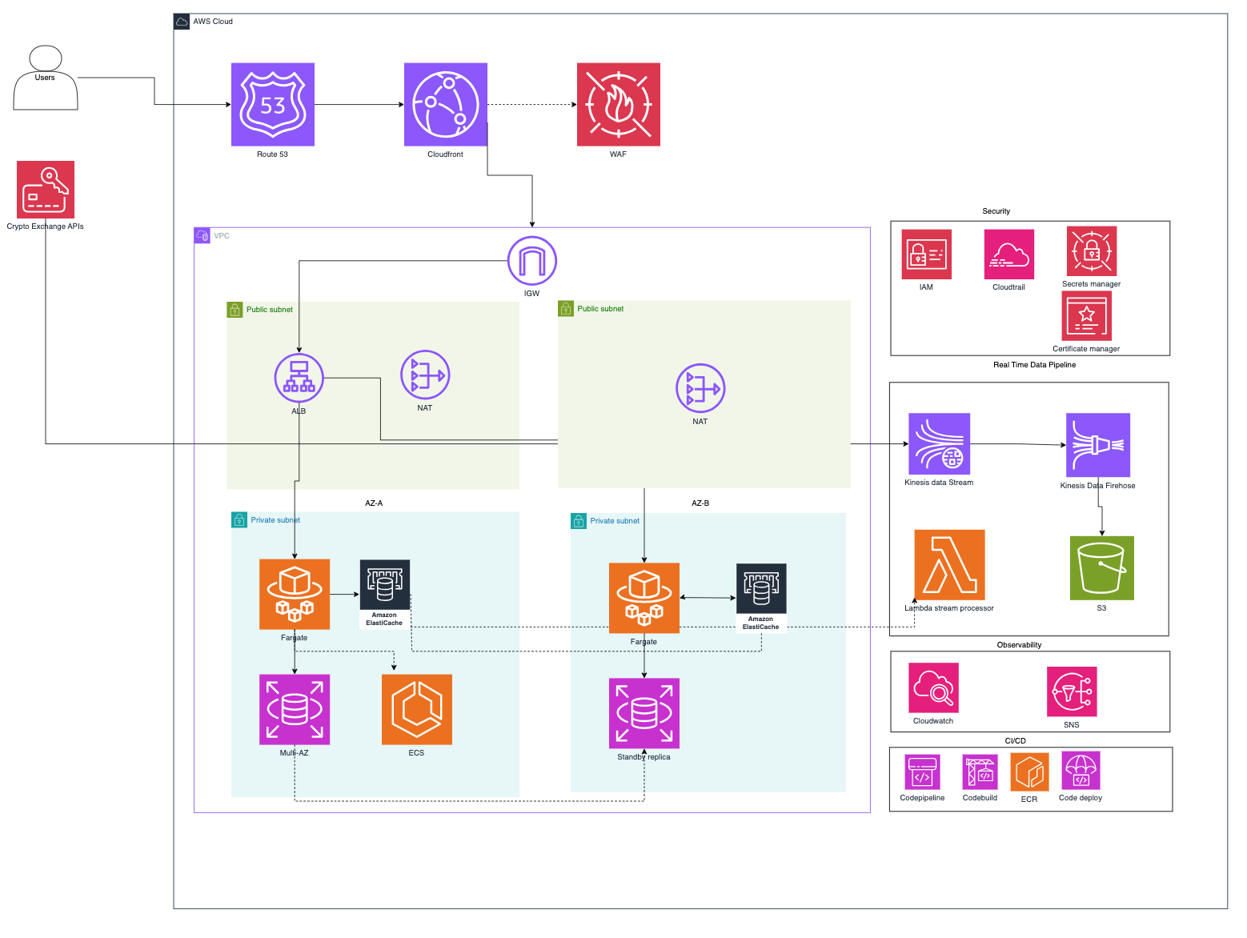

5. Outcomes

Metric | Result
99.95% | Platform availability sustained across rolling 90-day periods post-launch.
< 1 sec | Median page load time for article and market data pages globally via CloudFront edge delivery.
15× Spike | Peak traffic successfully absorbed during major crypto market volatility events zero downtime.
Real-Time | Live pricing, market heatmaps, and AI news summaries delivered continuously with sub-second data freshness.

6. About Kiwi Koru Limited
Kiwi Koru Limited is a cloud architecture and engineering consultancy helping technology companies design, build and operate scalable, resilient systems on AWS. We bring deep expertise in high-availability architecture, real-time data platforms, and production infrastructure engineering.

